Experiment - 6
NAME: Yuvaraj A ROLL NO:240701809
Simulate the lifecycle stages for UI design using the RAD model and develop a small interactive interface using Axure RP

Welcome Screen
- This is the initial screen of the BeatBox music application.
- It welcomes users with the app name and logo.
- It provides options such as Sign Up and Log In.
- These buttons are used for navigation in the prototype.
- The design is simple, clean, and attractive.
- It gives users a basic introduction to the application.
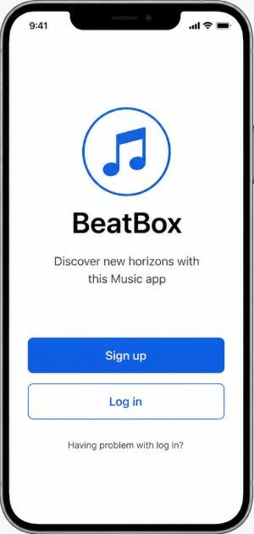

Sign Up Screen
- This screen is designed for new user registration.
- It contains fields such as Username, Email, and Password.
- A Sign Up button is provided to continue registration.
- Social sign-up options are added for design purpose.
- No real data is stored, it is only a prototype.
- It helps visualize the registration process of the app.
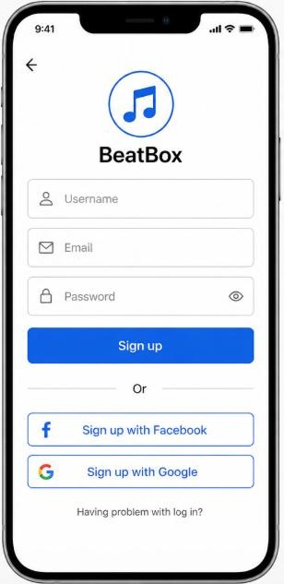

3. Music Player Screen
- This screen represents the music player interface.
- It displays song details like title and artist name.
- It includes controls such as Play, Pause, Next, and Previous.
- A progress bar is shown to indicate song duration.
- Buttons are used to simulate interaction in the prototype.
- It gives an idea of how the final BeatBox music app will function.

